CAPE
RPA Development Skill
AI-Assisted RPA Development Knowledge and Productivity Enhancement

Introduction

RPA Context at Inchcape
Inchcape's Robotic Process Automation (RPA) capability operates within a multi-platform and cost-conscious technology ecosystem designed to select the most appropriate automation technology according to the characteristics, complexity, and requirements of each process. The current RPA technology landscape comprises four principal components: AutoDrive, Power Automate Cloud, UiPath, and Azure AI Foundry / Databricks.
- AutoDrive: the team's in-house Python-based automation framework, representing the default technology choice for new automation initiatives. It incorporates technologies such as PyAutoGUI, pywin32, Selenium, and OpenCV to support user-interface automation and data-processing activities.
- Power Automate Cloud: is primarily used for automation scenarios within the Microsoft ecosystem, including workloads involving SharePoint, Forms, and Teams.
- UiPath: is reserved for more complex enterprise automation scenarios where the capabilities of the in-house framework are insufficient, particularly when processes involve multiple applications, persistent state, or enterprise-grade orchestration requirements.
- Azure AI Foundry and Databricks: provide capabilities for artificial intelligence and machine-learning use cases, including intelligent document processing.
This diversity allows the RPA team to select appropriate technology for different automation scenarios; however, it also means that developers must understand the capabilities, limitations, development practices, and appropriate use of several platforms rather than relying on a single technology stack.
The technical complexity of the environment is complemented by an established RPA delivery lifecycle that governs how automation initiatives move from an initial request to operational use. The Project Intake Framework defines ten phases that include:
- Request & Approval
- Discovery & Scoping
- Project Documentation
- Architecture Review
- Development
- User Acceptance Testing (UAT)
- Internal Change Advisory Board (CAB) Review
- Global Change Advisory Board (CAB) Review
- Deployment
- Hypercare & Business-as-Usual (BAU) Handover
As a result, successful RPA development involves considerably more than producing an automation that technically performs its intended task. Developers must also consider architecture, security, access management, testing, documentation, change management, operational requirements, and other organizational controls throughout the lifecycle. The ability to develop effectively is therefore closely connected to the developer's ability to understand and apply the knowledge surrounding the technology.

The RPA Knowledge Environment
Over time, the RPA team has established a substantial internal knowledge base to support this technical and operational environment. Much of this knowledge is maintained through the team's Confluence spaces and covers areas such as RPA strategy and architecture, service definitions, development standards, security guidelines, access procedures, CAPTCHA and MFA policies, critical-incident management, data governance, change management, solution documentation, role definitions, and project-specific information. In addition, Service Desk information provides an operational perspective through incidents and support activities, complementing the more structured knowledge contained within the team's documentation.
This existing knowledge is a significant organizational asset, yet its availability does not necessarily guarantee efficient access to it. When a developer encounters a technical or process-related question, finding the answer may involve searching through several documents, determining which source is applicable, interpreting the information in the context of the current automation, and, when uncertainty remains, consulting another member of the team. This can occur even with relatively routine questions involving:
- Development standards and coding practices;
- Platform or technology selection;
- Access, credentials, and security requirements;
- Debugging and troubleshooting;
- Integrations and APIs;
- Testing and quality practices;
- Documentation and governance;
- CAB and change-management requirements; and
- Incident handling and operational procedures.
The resulting friction is not necessarily caused by missing information. In many cases, the required knowledge already exists somewhere within the organization's documentation or accumulated team experience. The challenge lies instead in finding the relevant information, understanding its context, and applying it consistently at the moment it is needed. This distinction is important because it shifts the opportunity from creating yet another repository of information toward improving the way existing knowledge can be accessed and used.

CAPE as an Opportunity for Knowledge Accessibility
This opportunity emerged from the practical use of CAPE (Capability Accelerator Productivity Engine) and from observing how its existing capabilities could be applied to the RPA development environment. CAPE already provides an AI-enabled platform with reusable Skills and connections to organizational sources, including Confluence and read-only Service Desk capabilities. Its Skill-based architecture makes it possible to introduce specialized knowledge and behavior when they are relevant to a user's request, creating an opportunity to extend CAPE beyond its existing general-purpose capabilities and toward more specialized team use cases.
For the RPA team, this creates a particularly relevant possibility: instead of introducing another platform, another knowledge repository, or another standalone AI assistant, a specialized capability can be developed within a tool that is already available. The proposed RPA Development Skill can therefore serve as a knowledge and productivity layer over the existing RPA ecosystem, helping developers interact with relevant internal knowledge through a more contextual and accessible interface. The conceptual relationship is illustrated in Figure 1.
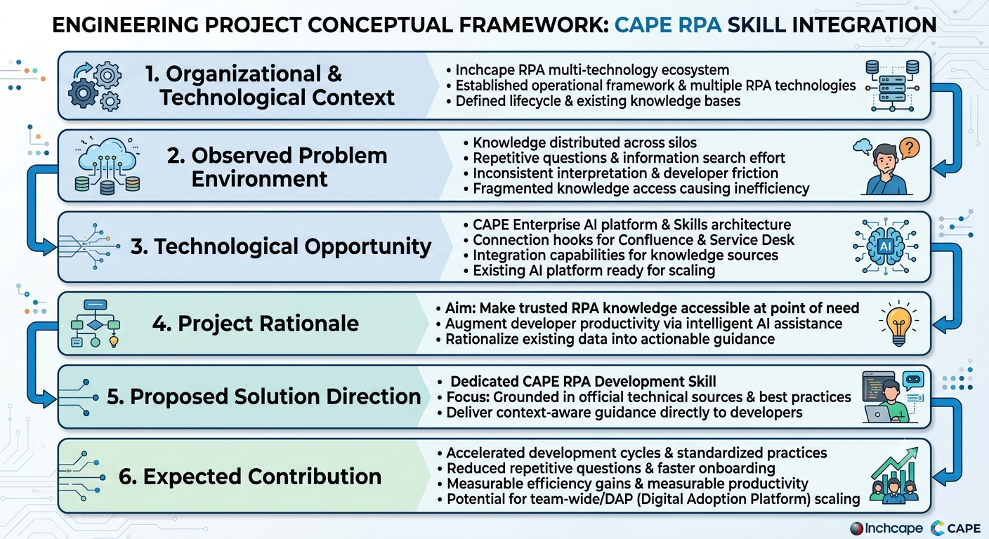
Figure 1. Conceptual Framework for the CAPE RPA Development Skill Initiative
The role of the Skill should nevertheless be clearly defined. It is not intended to replace Confluence as the source of organizational documentation, Service Desk as an operational system, experienced developers as sources of expertise, or formal processes such as architecture review, security approval, and CAB. Rather, its purpose is to help developers reach and interpret relevant information more efficiently while preserving the authority of those underlying sources and processes. CAPE provides the technological foundation; the RPA Development Skill provides the domain-specific knowledge, context, and behavioral guidance necessary to turn that foundation into a practical development capability.

From Knowledge Accessibility to Developer Productivity
The value of improving knowledge accessibility ultimately depends on whether it changes the way developers work. If a developer can obtain relevant and reliable guidance without repeatedly searching through documentation or asking the same questions to other team members, part of the time currently spent on information discovery can instead be directed toward implementation, debugging, testing, or other activities that contribute directly to delivery. At the same time, grounding responses in established RPA practices can help reduce variations in how similar technical situations are interpreted and addressed, creating a potential link between faster knowledge access and greater consistency in development practices.
This relationship defines the central premise of the initiative:
Better access to trusted and contextualized knowledge should contribute to greater developer efficiency and consistency.
The purpose is therefore not to build an AI assistant simply because AI can answer questions. A useful RPA Development Skill must address actual development needs and provide guidance that developers can reasonably use in their daily work. Its responses should be relevant to the context provided, aligned with applicable Inchcape practices, technically grounded in reliable sources, and sufficiently actionable to help the developer determine what to do next. Equally important, the Skill should recognize the limits of its available knowledge: when information is incomplete, conflicting, or insufficient to support a reliable recommendation, it should make that limitation explicit rather than present an unsupported answer with unwarranted confidence.
This perspective also introduces an important distinction between knowledge availability and knowledge usability. The RPA team may already possess the information necessary to resolve a problem, but if accessing that information requires considerable searching, interpretation, or interpersonal consultation, the knowledge is not being used as efficiently as it could be. The proposed initiative seeks to reduce this gap.

Proposed Initiative
Based on this opportunity, the first initiative proposed within CAPE is the development of a dedicated RPA Development Skill. The decision to begin with a single Skill is intentional: rather than attempting to develop multiple RPA-related capabilities simultaneously, the project will focus on one well-defined use case, establish what effective behavior looks like, and determine whether the resulting capability produces measurable value before considering broader expansion. This approach keeps the initial scope manageable while allowing the project to generate practical evidence that can inform subsequent decisions.
The Skill will be centered on the knowledge and activities most relevant to the team's day-to-day development work. Its initial scope is expected to cover the following areas:
- RPA platform and architecture decisions: guidance on technology selection, architectural considerations, platform capabilities, limitations, and appropriate solution approaches across the technologies supported by the team
- Development standards and coding practices: implementation patterns, coding conventions, maintainability, software engineering practices, and standards applicable to RPA development.
- Debugging and troubleshooting: structured approaches for investigating technical problems, identifying likely causes, interpreting errors, and selecting appropriate remediation strategies.
- API and system integrations: guidance for integrating RPA solutions with external applications, APIs, services, databases, and other systems within the team's supported environment.
- Testing and quality practices: testing strategies, validation approaches, quality considerations, and practices that support reliable and maintainable automation.
- Logging and exception handling: approaches for observability, error management, exception handling, diagnostic information, and operational resilience.
- Security and credential management: secure handling of credentials, authentication, access requirements, sensitive information, and applicable security controls.
- Documentation and governance requirements: solution documentation, development documentation, lifecycle requirements, governance practices, and other organizational expectations.
- CAB, change management, and operational processes: guidance related to change requests, CAB requirements, deployment considerations, hypercare, BAU transition, and associated procedures.
- Incident management and operational support: interpretation of relevant incident-management procedures, support practices, and operational information available through the team's knowledge sources.
- Interpretation of internal RPA documentation: contextual assistance in locating, understanding, and applying Inchcape-specific documentation, standards, procedures, and established practices.
- Technology-specific technical guidance: questions involving the team's supported platforms and technologies, including their development frameworks, libraries, services, and relevant technical practices.
These areas represent the initial capability scope rather than a fixed boundary. The final scope should be refined according to the actual needs identified during the project, particularly recurring questions, knowledge-search activities, and development scenarios in which the Skill can provide a demonstrable efficiency benefit. This distinction is important because the objective is not to create an exhaustive repository of everything related to RPA, but to develop a focused capability around the knowledge developers most frequently need to access and apply.
The Skill should therefore not attempt to answer every possible RPA question simply because the underlying technology makes it possible. Its usefulness will depend on maintaining a clear relationship between the knowledge it provides and the problems developers actually need to solve. Where a question falls outside the Skill's reliable knowledge or organizational authority, the appropriate behavior may be to identify the limitation, request additional context, direct the developer toward the relevant source, or recommend escalation through the established process rather than provide an unsupported recommendation.
The knowledge supporting the Skill will follow the same principle of relevance and authority. Internal Inchcape documentation should take precedence for organization-specific policies, processes, standards, and governance requirements, while official vendor documentation and other authoritative technical sources can provide additional depth for technology-specific questions. Industry standards and academic sources may be incorporated where they offer relevant engineering principles or theoretical foundations. The detailed source strategy, including source selection, validation, prioritization, currency, and maintenance, will be defined later in this document.

Initial Project Direction
The project's initial direction is defined by a simple but consequential objective: the RPA Development Skill should make developers faster and more consistent. This principle comes directly from the challenge established for the initiative and provides the criterion against which design decisions should ultimately be evaluated. A feature, source, behavior, or capability should therefore be considered valuable when it contributes to that objective rather than merely increasing the apparent sophistication or breadth of the Skill.
The initial development approach will follow four closely related activities:
- Identify: determine the recurring questions, knowledge-search activities, pain points, and development scenarios where AI assistance could provide meaningful value.
- Design: define the Skill's knowledge structure, source hierarchy, response behavior, and boundaries around those real-world needs.
- Build and test: develop a usable version and evaluate it against representative RPA development scenarios and questions.
- Measure and refine: assess the capability based on technical correctness, consistency, usefulness, trustworthiness, and evidence of efficiency improvement, then iterate accordingly.
The validation of the initial capability will be guided by a set of practical questions that translate the project's objective into observable outcomes:
- Efficiency: Does the Skill reduce the time developers spend searching for relevant information?
- Repetition: Does it reduce repetitive questions that are repeatedly directed toward experienced team members?
- Consistency: Does it provide consistent guidance when developers encounter recurring or equivalent technical questions?
- Standards alignment: Does it correctly apply established RPA standards, development practices, security requirements, and governance procedures?
- Usefulness and trust: Do developers consider its responses sufficiently relevant, actionable, and trustworthy to incorporate into their daily workflow?
- Productivity value: Does repeated use demonstrate a measurable improvement in the efficiency of relevant development activities?
These questions are intentionally presented at a high level at this stage. They establish what the project needs to demonstrate without prematurely defining the complete evaluation methodology. The detailed evaluation framework will subsequently translate these questions into a baseline, test scenarios, metrics, scoring criteria, and acceptance thresholds.
The project is therefore intended to be evidence-driven rather than capability-driven. The existence of a functioning Skill will not, by itself, constitute success. Instead, the project should demonstrate that the capability provides a meaningful improvement over the current approach to accessing and applying RPA knowledge. Particular attention should be given to the reduction of repetitive information-seeking activities and to the consistency of technical guidance, since both directly reflect the efficiency and consistency objectives established for the initiative.
If the initial implementation demonstrates sufficient value, the next step will be to refine the Skill and consider its integration into the team's normal development practices. Only after the first capability has been demonstrated should the project move toward additional RPA-related Skills or broader adoption across DAP. This staged approach limits unnecessary scope during the initial implementation while preserving a clear path from proof of value to team adoption and, if the results justify it, potential organizational expansion, as illustrated in Figure 2.
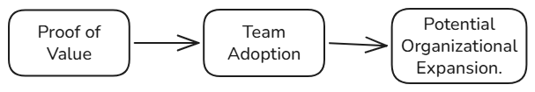
Figure 2. Proposed Adoption Path for the RPA Development Skill

Document Purpose
This document defines the project and technical approach for the design, development, evaluation, and potential adoption of the CAPE RPA Development Skill. It is intended to serve as a working blueprint for the initiative, establishing the reasoning behind the project, the problem it seeks to address, the objectives that define success, the proposed capability, the knowledge and behavioral principles that should govern it, and the approach that will be used to validate its effectiveness.
The document is deliberately designed to evolve with the project. As the Skill is researched, implemented, tested, and refined, it will capture the decisions made, the evidence collected, the lessons learned, and the changes introduced between iterations. It will therefore function both as a practical development guide and as a record of how the initial concept is progressively transformed into a validated capability that can be considered for broader use.
At its core, the initiative follows a straightforward progression:
- Existing knowledge: Inchcape's RPA environment contains substantial technical, operational, and organizational knowledge accumulated through its documentation, processes, technologies, and team experience.
- Developer need: developers must repeatedly access and apply this knowledge throughout the automation lifecycle, often while solving time-sensitive technical or operational questions.
- Technological opportunity: CAPE provides an existing AI-enabled mechanism through which access to relevant organizational knowledge can potentially be made more contextual, efficient, and actionable.
- Focused capability: the RPA Development Skill provides a controlled way to test whether this opportunity can translate into measurable improvements in developer efficiency and consistency.
The remainder of this document develops this proposition into a concrete, testable, and potentially scalable approach, moving from the definition of the current problem and project objectives through the Skill's knowledge strategy, behavioral design, implementation, evaluation, pilot, and potential adoption

